SRG Run 17 – 5.2km Morphett Vale ‘Block run’
- 5.2km course
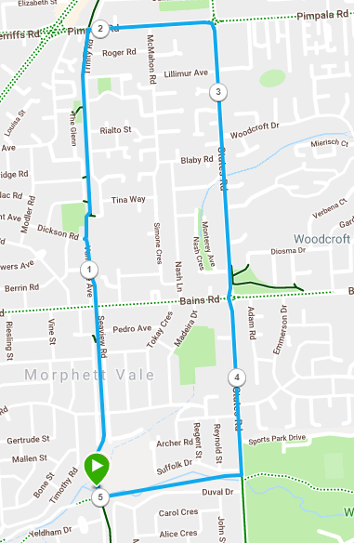
Directions:
- Follow Coast to Vines track across Bains road until you reach Pimpala road (Hungry Jacks)
- Turn right until States Road (Roundabout)
- Turn right and follow until the Christies Creek trail, just after Duvall ave
- Turn right and follow the path back to the park
SRG Run 17 – 10.2km Morphett Vale ‘Block run’
- 10.2km course
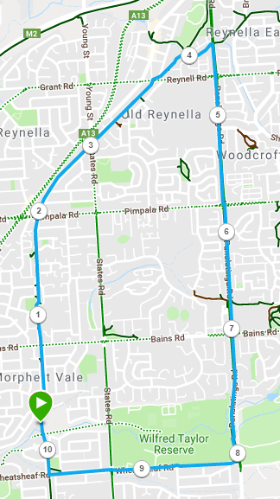
Directions:
- Follow the Coast to Vines trail across Bains, Pimpala, States and Reynell roads until you reach the small bridge
- Immediately after the bridge turn right and follow the track to Panatalinga road
- Turn right and follow Panatalinga until you reach Wheatshead road
- Turn right and follow back to the Coast to Vines trail
- Turn right and return to the park

SRG Run 17 – 18.9km Morphett Vale ‘Block Run’
- 18.9km course
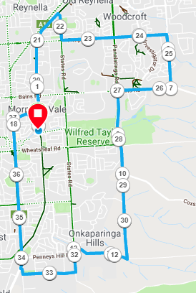
Directions:
- Follow the Coast to Vines trail across Bains and Pimpala roads, until States road
- Turn right and follow States road until the Pimpala road roundabout and turn left
- Follow Pimpala across Panatalinga road until Knox road (opposite Sir James Hardy Way) and turn right
- Run to the end and turn right onto Bains Road
- Turn left onto Panatalinga road – continue past Wheatshead road and straight ahead at the bend, through the sandy trail section, continue up Kimbly road until the T-Section with Upper Penney Hills road and turn right
- At the end, turn left into States road and continue up the hill until Cottage Terrace
- Turn right into Cottage Terrace and run to the end
- Turn right and continue onto Main South road, crossing Honeypot, Doctors and Wheatsheaf roads
- Turn right into Randell road and run until the bridge
- Turn right and follow the road and track back to the park

