SRG Run 10 – 5.1km Reynella loop run
- 5.1km course
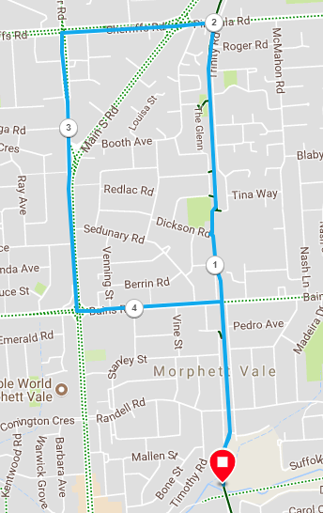
Directions:
- From the park, follow track across Bains Road and continue on to Pimpala road (Junk Food corner)
- Turn left and cross Main South road, continuing along Sherriffs road until Hillier road
- Turn left at Hillier road and run to Bains road
- Turn left and run until the bike track
- Turn right and follow the bike track back to the park
SRG Run 10 – 10.5km Reynella loop run
- 10.5km course
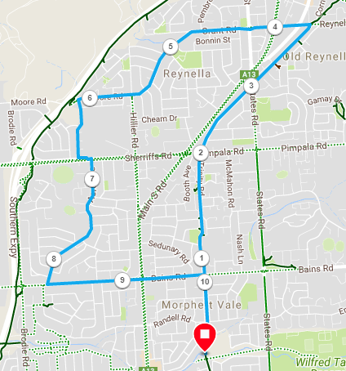
Directions:
- Follow track towards Bains Rd, cross Bains Rd until Pimpala Rd (Hungry Jacks)
- Continue along track, across States rd until Old Reynella Bus interchange and take next left into Reynell Rd/Grant Rd
- Through traffic lights and up hill to roundabout
- Continue through through 1st roundabout. At next roundabout take left angled turn into The Strand
- Follow The Strand for 1.4km until roundabout near freeway entry. Turn left into Jessamine Ave
- Follow until Sherriffs Rd. Cross Rd then turn left and right into Acre Ave
- Follow Acre Ave until O’Sullivan’s Beach road (T-Section)
- Turn left and follow O’Sullivan’s Beach road, across Main South road, and continuing along Bains Road to the bike track
- Turn right onto the track and follow back to the park
SRG Run 10 – 20.0km Reyenella loop run
- 20.0km course
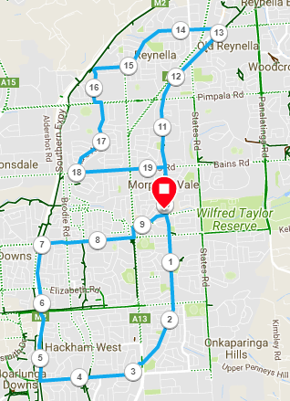
Directions:
- Follow the track South, across Wheatsheaf and Doctors road until you reach Honeypot road
- Cross over at traffic lights and follow Honeypot road, taking the right side service road to avoid traffic
- Just before the expressway turn right onto the expressway bike track towards Beach road (North)
- Continue along the track until just before Flaxmil road, when you take the exit track and turn right onto Wheatsheaf, until Main South road
- Turn left onto Main South road and turn right into the Emu Hotel carpark, continuing along the track until the park again
- (Join with 10km run group) Follow track towards Bains Rd, cross Bains Rd until Pimpala Rd (Hungry Jacks)
- Continue along track, across States rd until Old Reynella Bus interchange and take next left into Reynell Rd/Grant Rd
- Through traffic lights and up hill to roundabout
- Continue through through 1st roundabout. At next roundabout take left angled turn into The Strand
- Follow The Strand for 1.4km until roundabout near the expressway entry. Turn left into Jessamine Ave
- Follow until Sherriffs Rd. Cross Rd then turn left and right into Acre Ave
- Follow Acre Ave until O’Sullivan’s Beach road (T-Section)
- Turn left and follow O’Sullivan’s Beach road, across Main South road, and continuing along Bains Road to the bike track
- Turn right onto the track and follow back to the park

