SRG Run 2 – 5.2km Christies Creek trail ‘out & back’ run
- 5.2km course
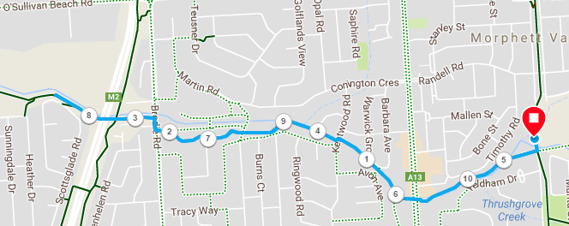
Directions:
- From the park, follow Christies Creek trail, continuing at road crossings until wetlands
- At Brodie Road, cross over and turn right briefly, then left and continue on the trail
- After passing under the expressway, continue for approximately 200 metres more, then return to the park the same way
SRG Run 2 – 10.4km Christies Creek trail ‘out & back’ run
- 10.4km course
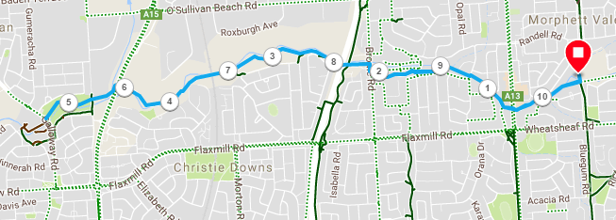
Directions:
- From the park, follow Christies Creek trail, continuing at road crossings until wetlands
- At Brodie Road, cross over and turn right briefly, then left and continue on the trail
- After passing under the expressway, continue until the track turns sharply to the right (seat next to track)
- Continue to follow the creek, down the track to the right and through the tunnel
- Continue up the rough track out of the tunnel, following the track as it crosses the creek again and reaches Dyson road
- Cross Dyson road and continue on the track which starts close to the guard railing over the creek
- Pass small footbridge and continue until you reach Galloway road
- Turn around and return to the park along the same track
SRG Run 2 – 20.1km Christies Creek trail ‘out & back’ run
- 20.1km course
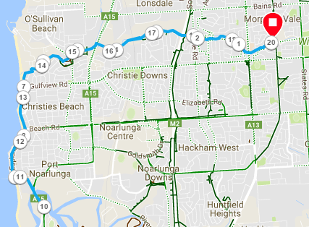
Directions:
- From the park, follow Christies Creek trail, continuing at road crossings until wetlands
- At Brodie Road, cross over and turn right briefly, then left and continue on the trail
- After passing under the expressway, continue until the track turns sharply to the right (seat next to track)
- Continue to follow the creek, down the track to the right and through the tunnel
- Continue up the rough track out of the tunnel, following the track as it crosses the creek again and reaches Dyson road
- Cross Dyson road and continue on the track which starts close to the guard railing over the creek
- Pass small footbridge and continue until you reach Galloway road
- Cross-over near the gate of the School, turn left down the service road then continue to follow the school fence along the track until you reach the SA water plan and service road/driveway
- Takes the service road and then run to the beach and follow the Esplanade track until Port Noarlunga
- After the jetty, continue on to Saltfleet bridge, cross over and run to the next roundabout (turnaround point)
- Turn around and return to the park along the same course

