SRG Run 15 – 5.4km Main South run
- 5.4km course
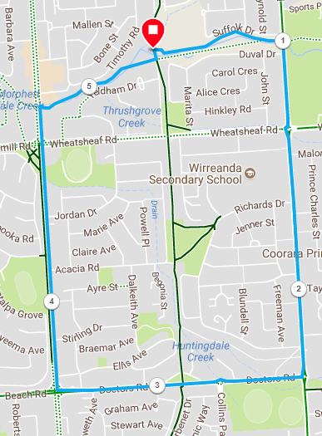
Directions:
- From the park, cross over the mound and pass the school until States road
- Turn right and run until Doctors road
- Turn right and run to Main South Road
- Turn right and run past Wheatsheaf, to the Emu Hotel carpark
- Turn into the Emu hotel, and then join the bike track to return to the park
SRG Run 15 – 10.6km Main South run
- 10.6km course
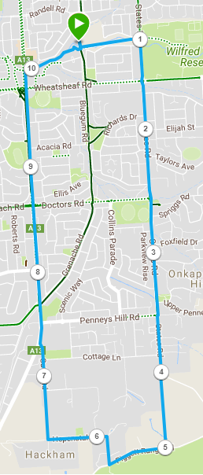
Directions:
- From the park, cross over the mound and pass the school until States road
- Turn right and run until Doctors road
- Continue straight ahead, passing Penney Hills road and Coattage Lane
- At the bend in the road, continue straight ahead onto the track section and back onto the road until you reach Piggot Range road
- Turn right and run until Hepenstal road
- Turn right and follow to the T-section (Gates road)
- Turn right and follow Gates down the hill until it joins Main South road
- Continue straight on to Main South road and run past Penney Hills road, Beach road and Wheatsheaf, to the Emu Hotel carpark
- Turn into the Emu hotel, and then join the bike track to return to the park

SRG Run 15 – 19.9km Main South run
- 19.9km course
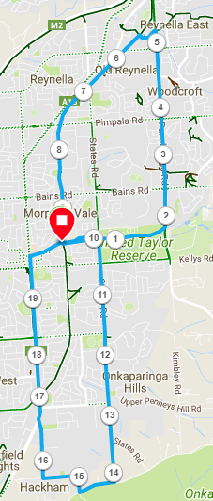
Directions:
- From the park, cross over the hill and down steps to school then follow track to States Road
- Continue across States road and follow track through reserve until you reach Panatalinga road and turn left
- Follow Panatalinga road across Bains, Pimpala and Reynell roads
- 300 metres after Reynel l road and immediately before Lantana Road turn left onto the footpath easy to miss it) and follow along creek line
- When you reach the coast to Vines trail (Bike track, turn left and cross the foot bridge then continue along the track back to the park
- (10km Run group start) From the park, cross over the mound and pass the school until States road
- Turn right and run until Doctors road
- Continue straight ahead, passing Penney Hills road and Coattage Lane
- At the bend in the road, continue straight ahead onto the track section and back onto the road until you reach Piggot Range road
- Turn right and run until Hepenstal road
- Turn right and follow to the T-section (Gates road)
- Turn right and follow Gates down the hill until it joins Main South road
- Continue straight on to Main South road and run past Penney Hills road, Beach road and Wheatsheaf, to the Emu Hotel carpark
- Turn into the Emu hotel, and then join the bike track to return to the park

