SRG Run 7 – 5.1km Southern Expressway run
- 5.1km course
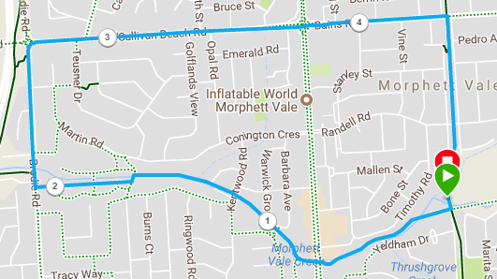
Directions:
- Follow Christies Creek trail until Brodie Road
- Turn right and run to O’Sullivans Beach Road
- Turn right and run until Main South Road, cross over and continue until bike track
- Turn right and follow back to the park
SRG Run 7 – 10.8km Southern Expressway run
- 10.8km course
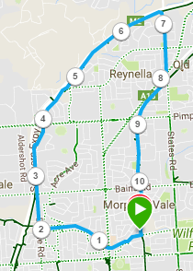
Directions:
- Follow Christies Creek trail until Brodie Road
- Turn right and run to O’Sullivans Beach Road
- Continue straight ahead and join the expressway track, continuing across Sherriffs road along the expressway
- Take the Young St exit, and turn right up Young st
- Cross over Mainsouth Road, then turn into States right and right onto the bike track
- Follow the track back to the park

SRG Run 7 – 22.1km Southern Expressway run
- 22.1km course
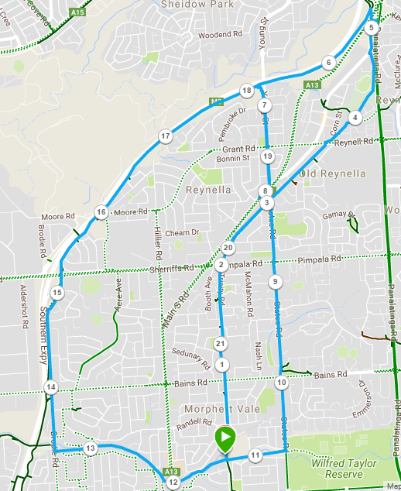
Directions:
- Follow the bike-track northwards until you reach Panatalinga road (near the expressway entry).
- Run down to the expressway track and turn left until Young St
- Take the exit and then turn right onto Young St, until Main South Road
- Cross over and turn into States road – continue along States road, crossing Pimpala and Bains road
- Just after Suffolk St, turn right onto the bike track and return to the park
- (10km runners) Follow Christies Creek trail until Brodie Road
- Turn right and run to O’Sullivans Beach Road
- Continue straight ahead and join the expressway track, continuing across Sherriffs road along the expressway
- Take the Young St exit, and turn right up Young st
- Cross over Mainsouth Road, then turn into States right and right onto the bike track
- Follow the track back to the park

