SRG Run 3 – 5.4km Coast to Vines trail ‘out & back’ run
- 5.4km course
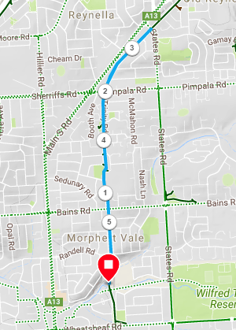
Directions:
- Starting at the park, follow the track towards Bains Road
- Continue across Bains road and Pimpala Road (Hungry Jacks)
- Continue along the track until the next cross road intersection (States road)
- **5km Turn-around** - turnaround and return to the park the same way
SRG Run 3 – 10.0km Coast to Vines trail ‘out & back’ run
- 10.0km course
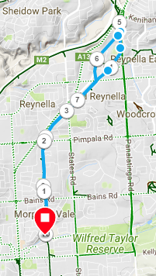
Directions:
- Starting at the park, follow the track towards Bains Road
- Continue across Bains road and Pimpala Road (Hungry Jacks)
- Continue on across Reynell road and follow the track until you reach the Panatalinga road traffic lights
- Follow footpath onto Panatalinga road (down the hill) and when you reach the old road bridge on the right, go to the right and re-join the Coast to Vines trail
- Follow trail back to the park
SRG Run 3 – 20.1km Coast to Vines trail ‘out & back’ run
- 20.1km course
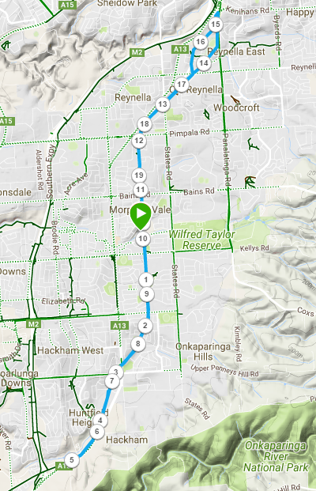
Directions:
- Starting at the park, run South along the Coast to Vines trail, crossing Wheatsheaf road, Doctor’s road and Honeypot roads
- Continue across Melsetter road (near Irish pub) until you reach the next road crossing (Brodie road), near the housing estate) – TURN AROUND and return to the park the same way.
- (Join 10k runners) - Follow the track towards Bains Road
- Continue across Bains road and Pimpala Road (Hungry Jacks)
- Continue on across Reynell road and follow the track until you reach the Panatalinga road traffic lights
- Follow footpath onto Panatalinga road (down the hill) and when you reach the old road bridge on the right, go to the right and re-join the Coast to Vines trail
- Follow trail back to the park

