SRG Run 18 – 4.8km Christies Creek Trail run
- 4.8km course
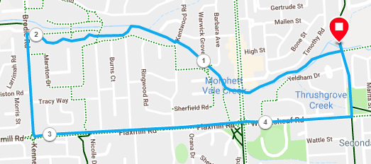
Directions:
- Follow the Christies creek trail until you reach Brodie road, just after the wetlands
- Turn left up Brodie road until the roundabout
- Turn left into Flaxmill road
- Cross over Main South road and continue until the Coast to Vines trail
- Turn left and follow the track back to the park
SRG Run 18 – 9.9km Christies Creek Trail run
- 9.9km course
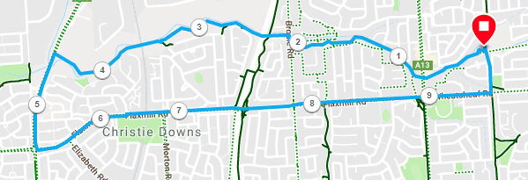
Directions:
- Follow the Christies creek trail until you reach Brodie road, just after the wetlands
- Turn right and left and continue along the Christies creek trail, under the expressway
- Continue straight ahead when you reach a sharp left bend in the track and go down the track and through the railway underpass tunnell
- Go up the hill on the other side and continue along the trail until you reach Dyson road
- Turn left onto Dyson road and run until the roundabout
- Turn left into Flaxmill road and continue all the weay until Main South road
- Cross over Main South road and continue until the Coast to Vines trail
- Turn left and follow the track back to the park

SRG Run 18 – 20.6km Christies Creek Trail run
- 20.6km course
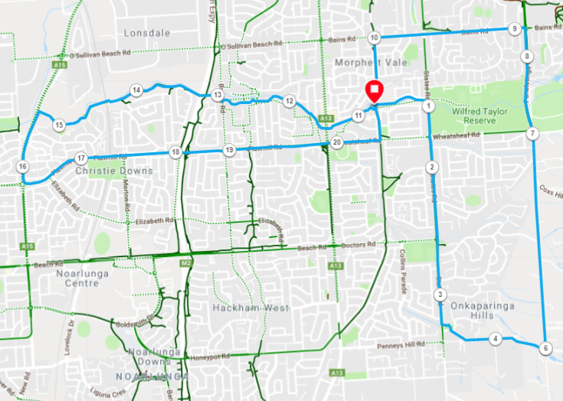
Directions:
- Run towards States road along the Christies Creek trail
- Turn right and run across Wheatsheaf and Doctors roads, until Upper Penney Hills road
- Turn left and follow Upper Penney Hills road until Kimberly and turn left
- Follow Kimbly road until the ropad swings to the left – at this point continue straight ahead along the fenceline and the track until the you reach the road on the other side
- Continue straight ahead, on to Panatalinga road until Bains road
- Turn elft and follow across States road until the Coast to Vines trail
- Turn left onto the track and follow it back to the park

- (With 10k runners) Follow the Christies creek trail until you reach Brodie road, just after the wetlands
- Turn right and left and continue along the Christies creek trail, under the expressway
- Continue straight ahead when you reach a sharp left bend in the track and go down the track and through the railway underpass tunnell
- Go up the hill on the other side and continue along the trail until you reach Dyson road
- Turn left onto Dyson road and run until the roundabout
- Turn left into Flaxmill road and continue all the weay until Main South road
- Cross over Main South road and continue until the Coast to Vines trail
- Turn left and follow the track back to the park

