SRG Run 23 – 5.0km Morphett Vale loop run
- 5.0km course
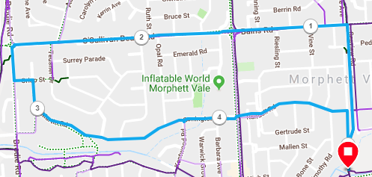
Directions:
- Follow track to Bains Rd then turn LEFT onto Bains Rd, across Main South Road until roundabout (Yes, up that hill!)
- Turn LEFT onto Brodie Road then first LEFT into Crisp St and RIGHT into Martin Road
- Follow Martin Road (and Connington Dr) back to Main South Road traffic lights
- Continue straight ahead and follow Randell Road till the bridge across the bike track
- TURN RIGHT and follow road down the hill and back to the park
SRG Run 23 – 10.2km Morphett Vale loop run
- 10.2km course
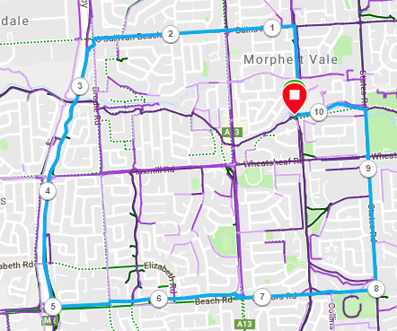
Directions:
- Follow track to Bains Rd then turn LEFT onto Bains Rd, across Main South Road until roundabout (Yes, up that hill!)
- Turn LEFT onto Brodie Road then join the expressway track and continue past Wheatsheaf and Elizabeth Roads, until Beach Road
- Take the Beach Road exit and turn left
- Follow Beach road across Main South Road and continue along Doctors Road until the end
- Turn left into States road
- Run across Wheatsheaf road and continue until the Christies Creek trail
- Turn left and follow the track back to the park

SRG Run 23 – 21.4km Morphett Vale loop run
- 21.4km course
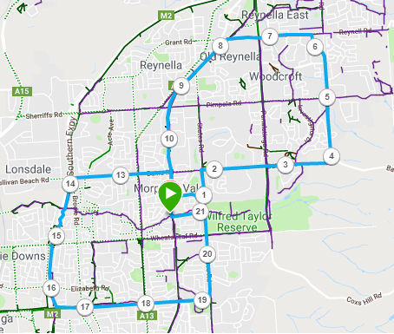
Directions:
- Run up the bike track and then onto the side road, until Randell Road
- Turn right and follow Randell road until States Road
- Turn left onto States Road until Bains Road and turn right
- Follow Bains Road across Panatalinga Road
- Continue along Bains Road and then turn left into Knox Road
- Follow Knox road across Pimpala Road, and continue along Sir James Hardy Way, until you reach Reynell Road
- Turn left and follow Reynell Road until the Coast to Vines trail
- Turn left and follow the track back to the park
With 10k runners:
- Follow track to Bains Rd then turn LEFT onto Bains Rd, across Main South Road until roundabout (Yes, up that hill!)
- Turn LEFT onto Brodie Road then join the expressway track and continue past Wheatsheaf and Elizabeth Roads, until Beach Road
- Take the Beach Road exit and turn left
- Follow Beach road across Main South Road and continue along Doctors Road until the end
- Turn left into States road
- Run across Wheatsheaf Road and continue until the Christies Creek trail
- Turn left and follow the track back to the park

