SRG Run 21 – 5.2km O’Sullivan’s run
- 5.2km course
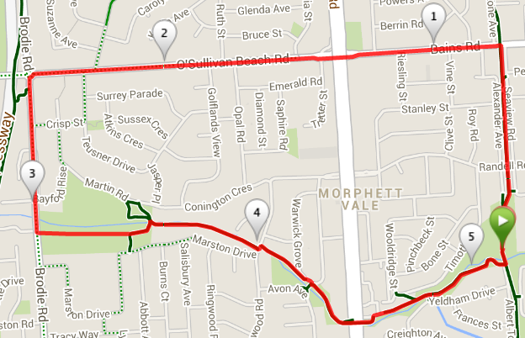
Directions:
- Run up the bike track to Bains Road, and turn left
- Cross Main South road and continue along O’Sullivan’s Beach road
- Continue until just before the expressway, then turn left into Brodie road
- Just after the shops and bridge turn left into the car park then onto the wetlands walking trail and follow until the houses, continuing along the creek trail, behind the houses
- Follow Christies Creek trail back to the park
SRG Run 21 – 10.9km O’Sullivan’s run
- 10.9km course
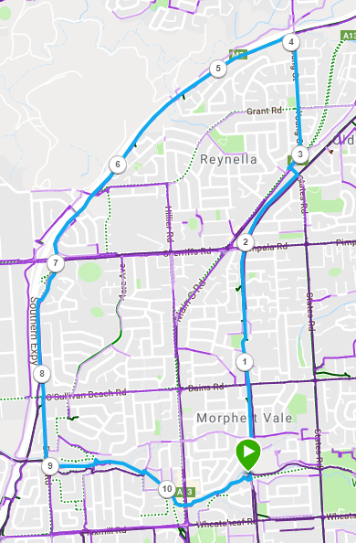
Directions:
- Run up the bike track and cross Bains and Pimpala Roads (Hungry Jacks) until you reach the next (States Road) crossing
- Turn left, then cross Main South road and turn right, then left again into Young St
- Continue until just before the expressway, then take the entry track onto the expressway path and turn left
- Follow track to Sherriffs road and continue along the footpath until you reach Brodie road
- When the expressway track moves away from Brodie road, continue along Brodie road
- Cross over O’Sullivan’s Beach road, then just after the shops and bridge turn left into the car park then onto the wetlands walking trail and follow until the houses, continuing along the creek trail, behind the houses
- Follow Christies Creek trail back to the park
SRG Run 21 – 22.0km O’Sullivan’s run
- 22.0km course
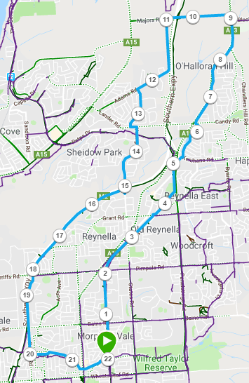
Directions:
- From the park follow the bike track across Bains, Pimpala, States and Reynell roads until you reach Panatalinga road
- Cross at the traffic lights onto Kennihans road then turn left into Fountain Valley road. At the end turn left into Tripoli road then left into Candy road
- Just before the traffic lights turn right onto the footpath and follow this past the O’Halloran Hill shops and continue along South road
- Pass Black road (on the right) and then take the next left into Majors road
- After crossing the expressway, take the next left road into Adams Road and follow this for approx. 2km then turn left into Heysen Drive
- Continue until Lander road (T-Section roundabout) then turn left and right into Young St
- Follow Young St until you cross over the expressway, then just after the bridge take the expressway track entry path to the right and then turn left and follow the expressway path.
- Follow track to Sherriffs road and continue along the footpath until you reach Brodie road
- When the expressway track moves away from Brodie road, continue along Brodie road
- Cross over O’Sullivan’s Beach road, then just after the shops and bridge turn left into the car park then onto the wetlands walking trail and follow until the houses, continuing along the creek trail, behind the houses
- Follow the Christies Creek trail back to the park

