SRG Run 1 - Morphett Vale ‘Block’ runs
- 4.9km course
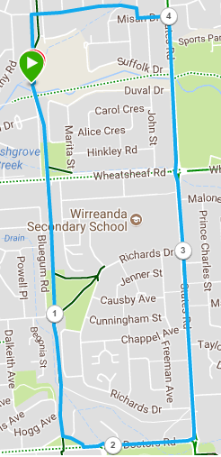
Directions:
- Run to Doctors Road – turn left
- Run to States Rd – turn left
- Cross-over Wheatsheaf Rd and continue onto Misan Drive – turn left
- Take first right and then left across verge and continue till bridge that crosses bike track
- Turn left immediately after bridge and follow road & track back to the park
SRG Run 1 - Morphett Vale ‘Block’ runs
- 9.9km course
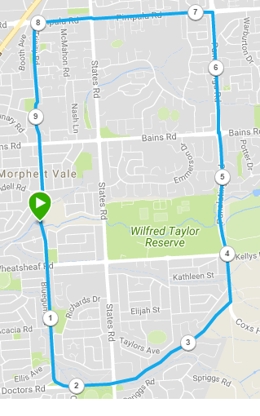
Directions:
- Run until Doctors Road – turn left
- Run to States Rd
- Cross-over onto track section and continue straight ahead, until you reach Panatalinga road (at the end) - turn left
- Follow Panatalinga road – cross Wheatsheaf, then Bains (Woodcroft shopping Centre) until Pimpala Rd – turn left
- Follow Pimpala until Hungry Jacks – Turn left just before it onto Bike track
- Follow track back to park

SRG Run 1 - Morphett Vale ‘Block’ runs
- 20.5km course
Directions:
- Follow track to Wheatsheaf road and turn left and run until Panatalinga rd
- Turn right into Panatalinga and continue onto Coxs Hill Road
- Take first right into Emu Creek road and follow till the end
- At the end, take the track immediately past the small shed on the right side of the road and go through the bush until you reach the fence on the other side – turn LEFT and join the road
- Turn left up Kimberly Road, up the hill and follow till the end
- Turn right into Upper Penney Hills Road and run till States Road
- Turn right into States road and continue across Wheatsheaf road till just after Christies Creek and turn left into Suffolk dr – turn left into Suffolk and follow to the left of the school and back to the park
- Turn left at the park, back onto the Coast to Vines trail and run across Wheatsheaf road until Doctors Road
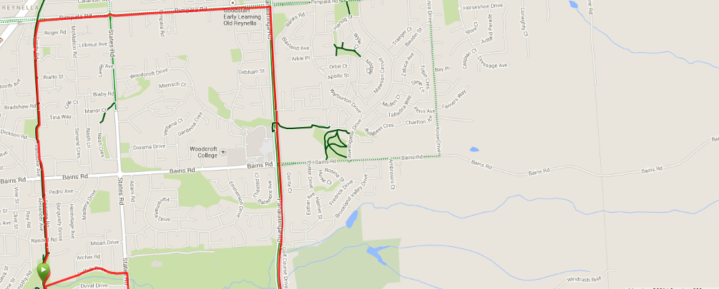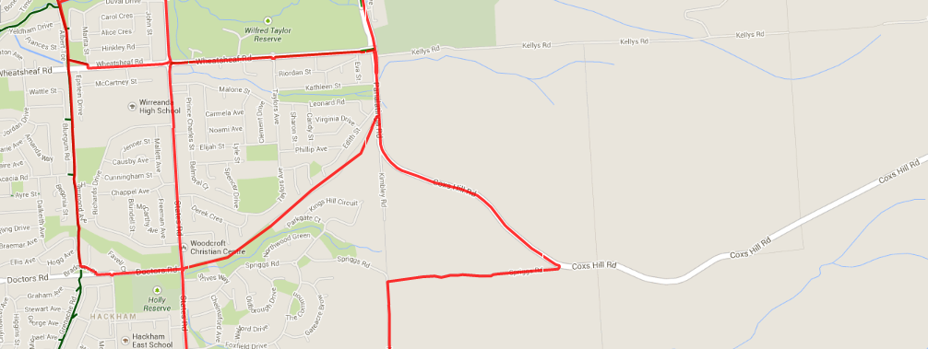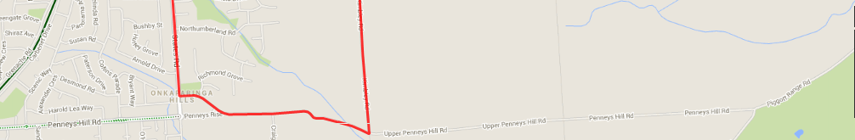
- Turn left and join Doctors Rd, straight through roundabout until T-Section (Roundabout) at States Rd
- Cross-over onto track section and continue straight ahead, until you reach Panatalinga road (at the end)
- Turn left and follow Panatalinga road – cross Wheatsheaf, then Bains (Woodcroft shopping Centre) until Pimpala (opposite Paramount Gym)
- Turn left and follow Pimpala until Hungry Jacks – Turn left just before it onto Bike track
- Follow track back to Park

