SRG Run 4 – 4.6km Panatalinga loop run
- 4.6km course
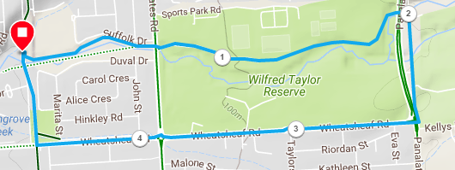
Directions:
- Starting at the park, cross over to the school and follow the track to States road
- Continue into Wilfred Taylor reserve, remaining on the track closest to the sporting fields
- Take the under-pass under Panatalinga road, then turn right and follow Golf Course drive and the track to the end of Wheatsheaf road
- Cross-over the follow Wheatsheaf road until the coast to Vines trail
- Follow the trail back to the park
SRG Run 4 – 10.4km Panatalinga loop run
- 10.4km course
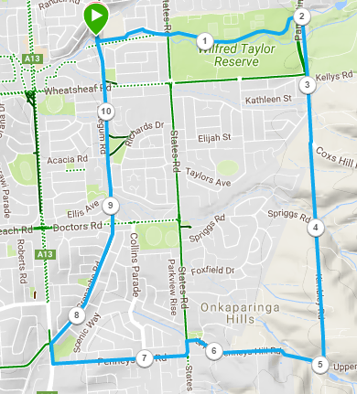
Directions:
- Starting at the park, cross over to the school and follow the track to States road
- Continue into Wilfred Taylor reserve, remaining on the track closest to the sporting fields
- Take the under-pass under Panatalinga road, then turn right and follow Golf Course drive and the track to the end of Wheatsheaf road
- Continue along Panatalinga road until the bottom of Cox’s Hill road, then go strateight ahead onto St Vincent’s View
- Continue through the trail section at the end of this road until it meets Kimberly road, then continue up the hill until the T-section with Upper Penney’s Hill road
- Turn right and follow till States road then turn left and right onto Penney’s Hill road
- At Main South road (Hungry Jacks) turn right and then right again onto the Coast to Vines trail
- Follow the trail back to the park
SRG Run 4 – 20.5km Panatalinga loop run
- 20.5km course
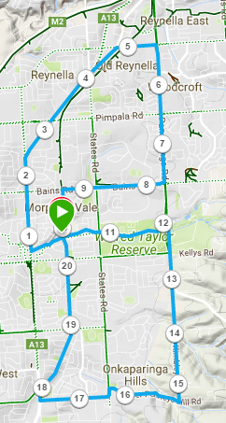
Directions:
- Starting at the park, follow Christies Creek trail to main South road and turn right
- Follow Main South road until after States road, then turntowards Old Reynella Bus Interchange
- At Reynel road, turn right until Panatalinga road
- Turn right into Panatalinga road and follow to Bains road (Woodcroft shopping centre)
- Turn right into Bains road and follow till the Coast to Vines trail – turn left and follow back to the park
- (Joining 10k runners) - Cross over to the school and follow the track to States road
- Continue into Wilfred Taylor reserve, remaining on the track closest to the sporting fields
- Take the under-pass under Panatalinga road, then turn right and follow Golf Course drive and the track to the end of Wheatsheaf road
- Continue along Panatalinga road until the bottom of Cox’s Hill road, then go strateight ahead onto St Vincent’s View
- Continue through the trail section at the end of this road until it meets Kimberly road, then continue up the hill until the T-section with Upper Penney’s Hill road
- Turn right and follow till States road then turn left and right onto Penney’s Hill road
- At Main South road (Hungry Jacks) turn right and then right again onto the Coast to Vines trail
- Follow the trail back to the park

