SRG Run 12 – 5.1km Christies loop run
- 5.1km course
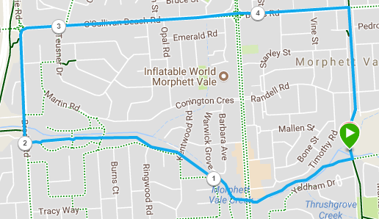
Directions:
- Follow Christies Creek trail towards Emu hotel, continuing through the tunnel until the wetlands
- Stay on left hand trail until you reach Brodie Road and turn right
- Pass shops and continue up road until roundabout. Turn right into O’Sullivans Beach Rd
- Follow O’Sullivan’s beach road until MS Road. Cross road and continue up Bains Rd till bike track
- Turn right into bike track and follow back to park
SRG Run 12 – 9.5km Christies loop run
- 9.5km course
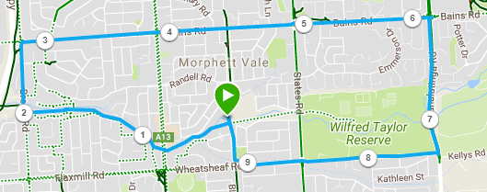
Directions:
- Follow Christies Creek trail towards Emu hotel, continuing through the tunnel until the wetlands
- Stay on left hand trail until you reach Brodie Road and turn right
- Pass shops and continue up road until roundabout. Turn right into O’Sullivans Beach Rd
- Follow O’Sullivan’s beach road until MS Road. Cross road and continue along Bains Road until Panatalinga road
- Turn right and follow Panatalinga and turn right again into Wheatsheaf road
- Follow Wheatsheaf road across States road, and then turn right onto the bike track and follow back to park
SRG Run 12 – 19.1km Christies loop run
- 19.1km course
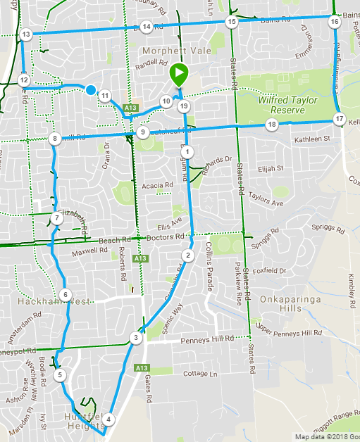
Directions:
- Follow track to Wheatsheaf road and continue on, crossing Doctors Road and Main South Road (Near Honeypot Rd)
- At next Road crossing (Near Irish Hotel) turn right into Melsetter road
- Just after Melfort Road, opposite the school entry, turn left onto the bike track
- Follow bike track across Honeypot Road, Glynville Drive (IGA), Beach Road, and under Elizabeth Rd, until Flaxmill Rd (path goes through tunnel)
- Turn right and follow Flaxmill to Main South road and continue on to bike track – turn left and return to park
- (10km run group start) Follow Christies Creek trail towards Emu hotel, continuing through the tunnel until the wetlands
- Stay on left hand trail until you reach Brodie Road and turn right
- Pass shops and continue up road until roundabout. Turn right into O’Sullivans Beach Rd
- Follow O’Sullivan’s beach road until MS Road. Cross road and continue along Bains Road until Panatalinga road
- Turn right and follow Panatalinga and turn right again into Wheatsheaf road
- Follow Wheatsheaf road across States road, and then turn right onto the bike track and follow back to park

