Onkaparinga National Park Runs – Chapel Hill (Gate 20) start point
- 6.3km course – Sundews trail
- https://connect.garmin.com/modern/course/137913340
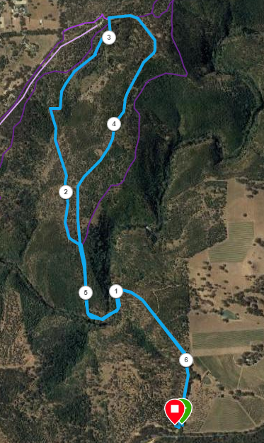
Directions:
- From Gate 20 follow Sundews Track (Fire trail) to the River crossing, and continue up the other side
- Near the top of the hill turn left where Sundews track crosses the first trail and continue until the track joins another wider track
- Turn left up the hill to near the main park entry
- Turn right near the sign and join the main road/Fire trail and follow this back down the hill, across the river and back up to the start
Onkaparinga National Park Runs – Chapel Hill (Gate 20) start point
- 11.0km course
- https://connect.garmin.com/modern/course/3031381

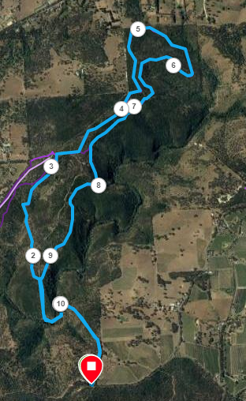
Directions:
- From Gate 20 follow Sundews Track (Fire trail) to the River crossing, and continue up the other side
- Near the top of the hill turn left where Sundews track crosses the first trail and continue until the track joins another wider track
- Turn left up the hill to near the main park entry
- Turn right near the sign and after 200 metres, turn left onto the Nature trail until you reach the next gate
- Follow the track to the right and again turn left after 150 metres onto Echidna trail
- Follow Echidna trail in a clockwise loop, then, turn left onto the Nature trail (signposted but not titled)
- Follow this track until you pass the lookout trail and continue until you reach the Fire trail and turn left down the hill towards the river
- Follow this back down the hill, across the river and back up to the start

Directions:
- Run until Doctors Road – turn left
- Run to States Rd
- Cross-over onto track section and continue straight ahead, until you reach Panatalinga road (at the end) - turn left
- Follow Panatalinga road – cross Wheatsheaf, then Bains (Woodcroft shopping Centre) until Pimpala Rd – turn left
- Follow Pimpala until Hungry Jacks – Turn left just before it onto Bike track
- Follow track back to park

Onkaparinga National Park Runs – Chapel Hill (Gate 20) start point
- 19.0km course – Chapel Hill Road, Bronzewing track, Sundews, Nature and Echidna trails
- https://connect.garmin.com/modern/course/137914774
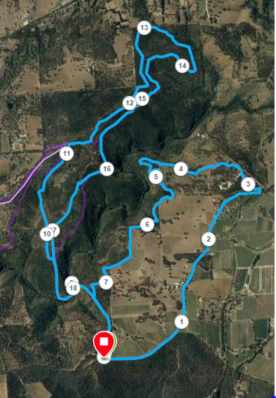
- Turn left up the hill to near the main park entry
- Turn right near the sign and after 200 metres, turn left onto the Nature trail until you reach the next gate
- Follow the track to the right and again turn left after 150 metres onto Echidna trail
- Follow Echidna trail in a clockwise loop, then, turn left onto the Nature trail (signposted but not titled)
- Follow this track until you pass the lookout trail and continue until you reach the Fire trail and turn left down the hill towards the river
- Follow this back down the hill, across the river and back up to the start
Directions:
- Follow Chapel Hill road for 3km, until you reach the entry gate to Onkaparinga NP on the left
- From the left side of the car park, follow the signs for the River Trail
- Part way down, at approx.. 4.5km join the narrow trail which heads cross country and joins Bronzewing trail
- Continue following Bronzewing trail until you reach Sundews track (Fire Trail) and then turn left and follow back to the start point.
Start of 11km run
- From Gate 20 follow Sundews Track (Fire trail) to the River crossing, and continue up the other side
- Near the top of the hill turn left where Sundews track crosses the first trail and continue until the track joins another wider track

- Turn left and join Doctors Rd, straight through roundabout until T-Section (Roundabout) at States Rd
- Cross-over onto track section and continue straight ahead, until you reach Panatalinga road (at the end)
- Turn left and follow Panatalinga road – cross Wheatsheaf, then Bains (Woodcroft shopping Centre) until Pimpala (opposite Paramount Gym)
- Turn left and follow Pimpala until Hungry Jacks – Turn left just before it onto Bike track
- Follow track back to Park

