Mt Bold Away runs

5.1km run Forest loop and Boundary trails
https://connect.garmin.com/modern/course/94637421
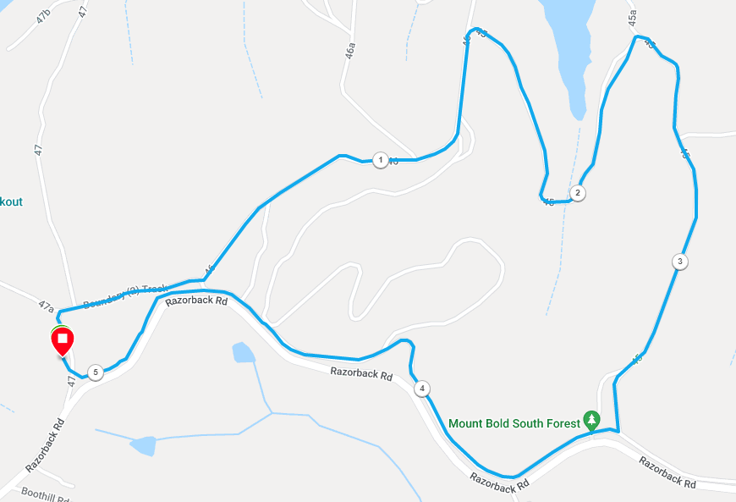

- Turn right just after the start and follow the Wedgetail/Forest loop trails

- At approx. 2.6km, continue straight (the 11.5k runners turn left) along track 45, following the Forest loop trail, until you reach the boundary track

- Turn right and follow the track along the boundary, staying close to the fence line all the way, until you arrive back at the main entry and car park.

11.5km run Wedgetail and Boundary trails
https://connect.garmin.com/modern/course/94635525
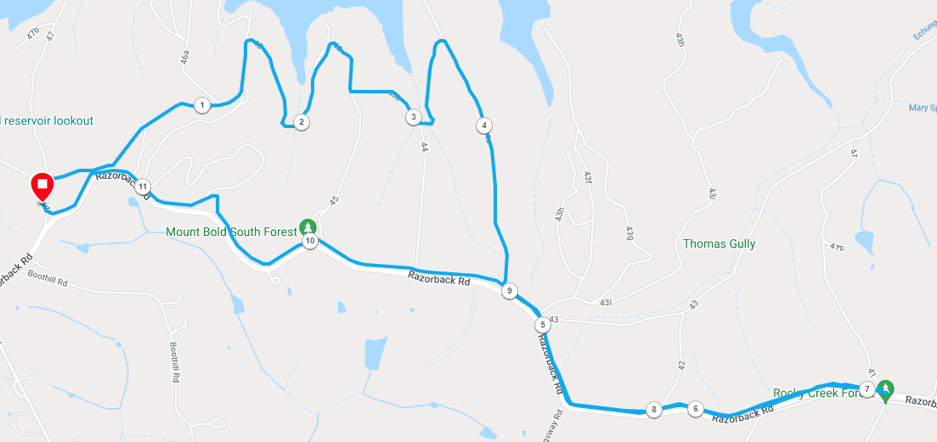

- Turn right just after the start and follow the Wedgetail/Forest loop trails

- At approx. 2.6km, turn left along track 45a

- Turn right again at track 44a and follow up the hill until you reach the boundary track

- Turn left and follow the out and back boundary track for 2km until you reach large trail map signs and smaller signs indicating restricted area

- Turnaround and follow trail 2km back to same point

- Continue straight along the boundary, staying close to the fence line all the way, until you arrive back at the main entry and car park.

